**Aim:** Analysis of Shark Tank US Dataset

**IDE:** Microsoft Excel, Tableau , Spyder

**Now Import Necessary Libraries for Analysis:-**

import pandas as pd

import matplotlib.pyplot as plt

import seaborn as sns

Dataset = pd.read_csv("./Shark Tank US dataset_Final.csv")

**Questions:**

1. **Which season is having the overall highest deal in terms of the amount?**

**Code:-**

Season_With_Highest_Amount = Dataset.loc[Dataset["Total Deal Amount"].idxmax(), "Season Number"]

plt.figure(figsize = (16,8))

plt.bar(x = ["Season_Numer"] , height=[Season_With_Highest_Amount] , width=0.5)

for i, values in enumerate([Season_With_Highest_Amount]) :

plt.text(i , values , str(values) , ha = 'center', va = 'bottom' , weight = 'bold')

plt.show()

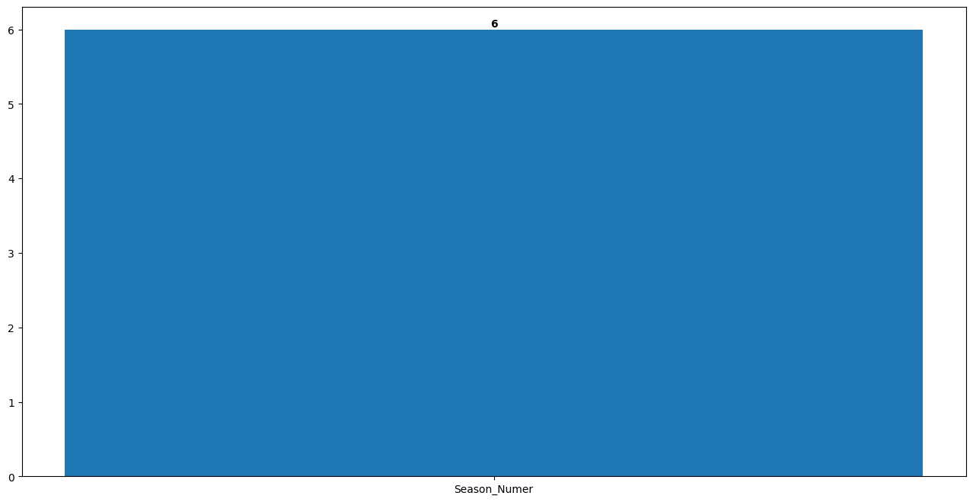**Output:-**

**Tableau Plot:-**

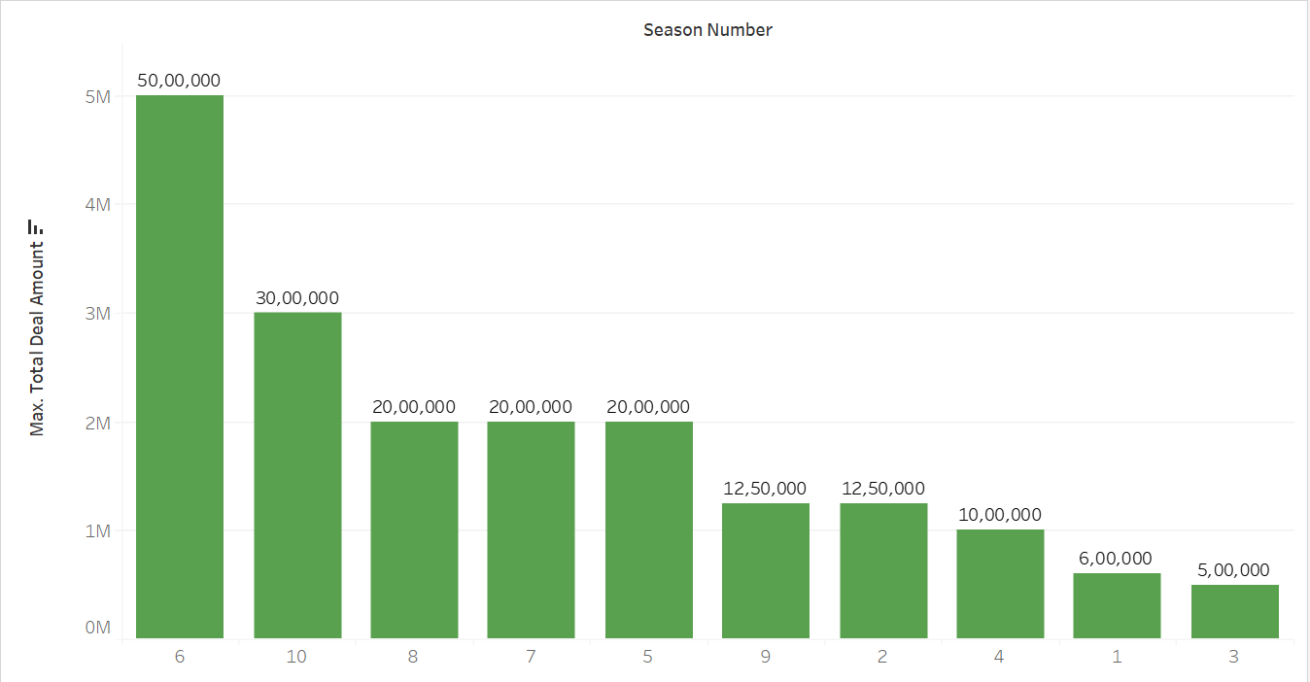

1. **Enlist episodes for each season having the highest deal in terms of the amount.**

**Code:-**

max_deal_episodes = Dataset.groupby("Season Number").apply(lambda x: x.loc[x["Total Deal Amount"].idxmax()])

colors = plt.cm.get_cmap("tab10", 10)

plt.figure(figsize=(12, 6))

bars = plt.bar(max_deal_episodes["Season Number"],max_deal_episodes["Episode Number"],color=colors(range(10)),)

plt.title("Episode with Maximum Deal Amount by Season")

plt.xlabel("Season Number")

plt.ylabel("Episode Number with Maximum Deal Amount")

for bar in bars:

yval = bar.get_height()

plt.text(bar.get_x() + bar.get_width() / 2, yval, int(yval), ha="center", va="bottom")

plt.xticks(max_deal_episodes["Season Number"])

plt.tight_layout()

plt.show()

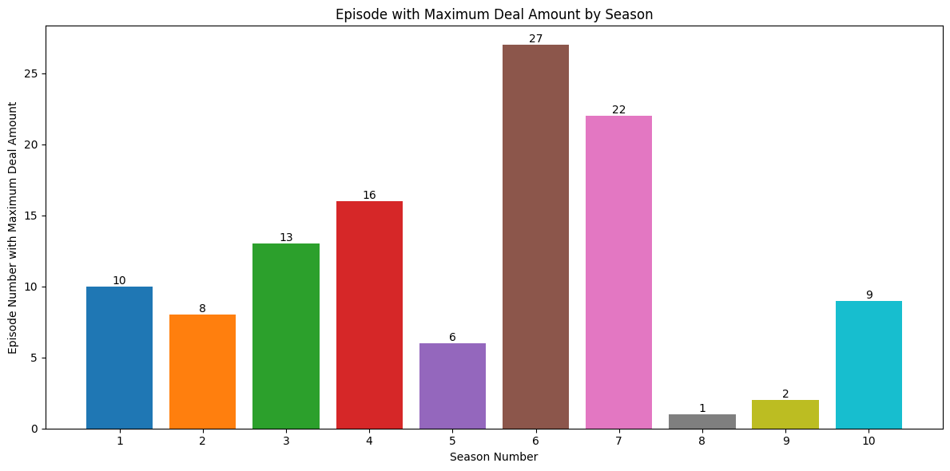**Output:-**

**Tableau Plot:-**

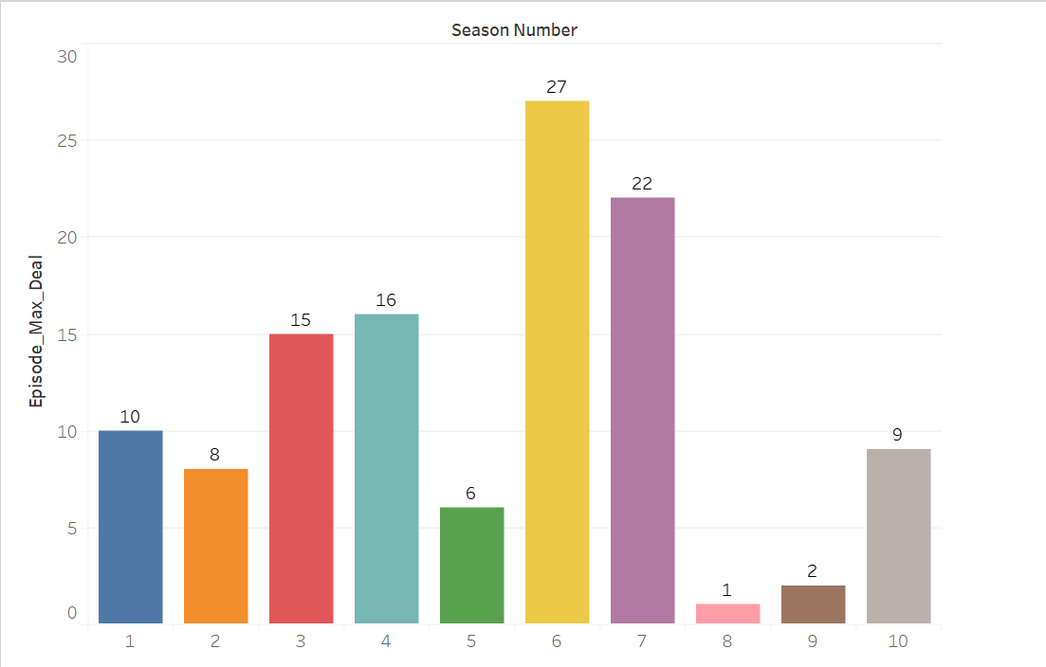

1. **Which are the top 10 deals in the shark tank?**

**Code:-**

Sorted_Deal = Dataset.sort_values(by="Total Deal Amount" , ascending=False)[:10]

Top_10_Deal = pd.DataFrame({"Startup Name" : Sorted_Deal['Startup Name'] , 'Total Deal Amount' : Sorted_Deal['Total Deal Amount']})

print(Top_10_Deal)

colors = plt.cm.get_cmap("tab10", 10)

plt.figure(figsize=(20,8))

plt.bar(x = Top_10_Deal['Startup Name'] , height=Top_10_Deal['Total Deal Amount'] , width=0.5 , color = colors(range(10)))

for i,value in enumerate(Top_10_Deal["Total Deal Amount"]) :

plt.text(i , value , str(value) , ha = "center" , va = "bottom" , weight = "bold")

plt.show()

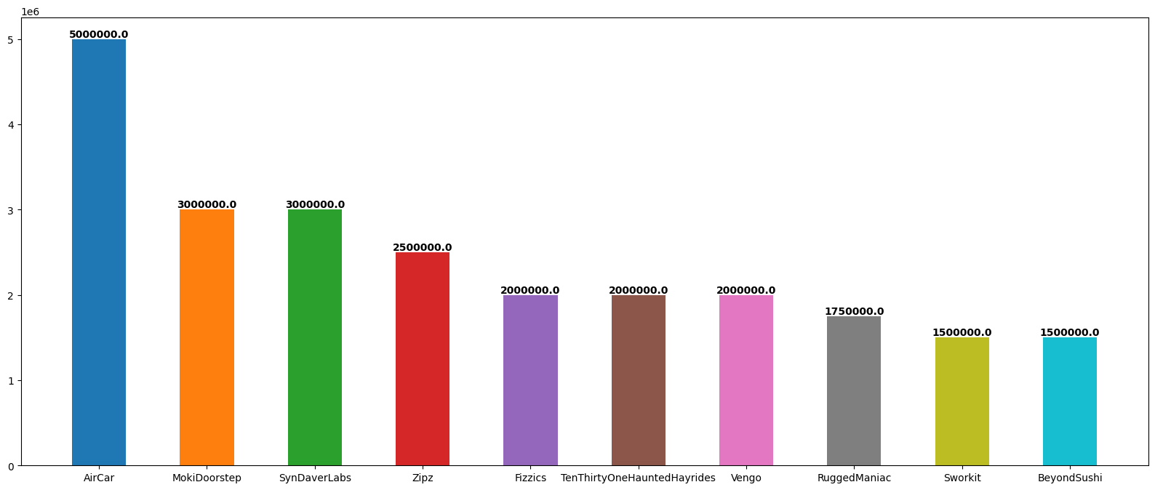**Output:-**

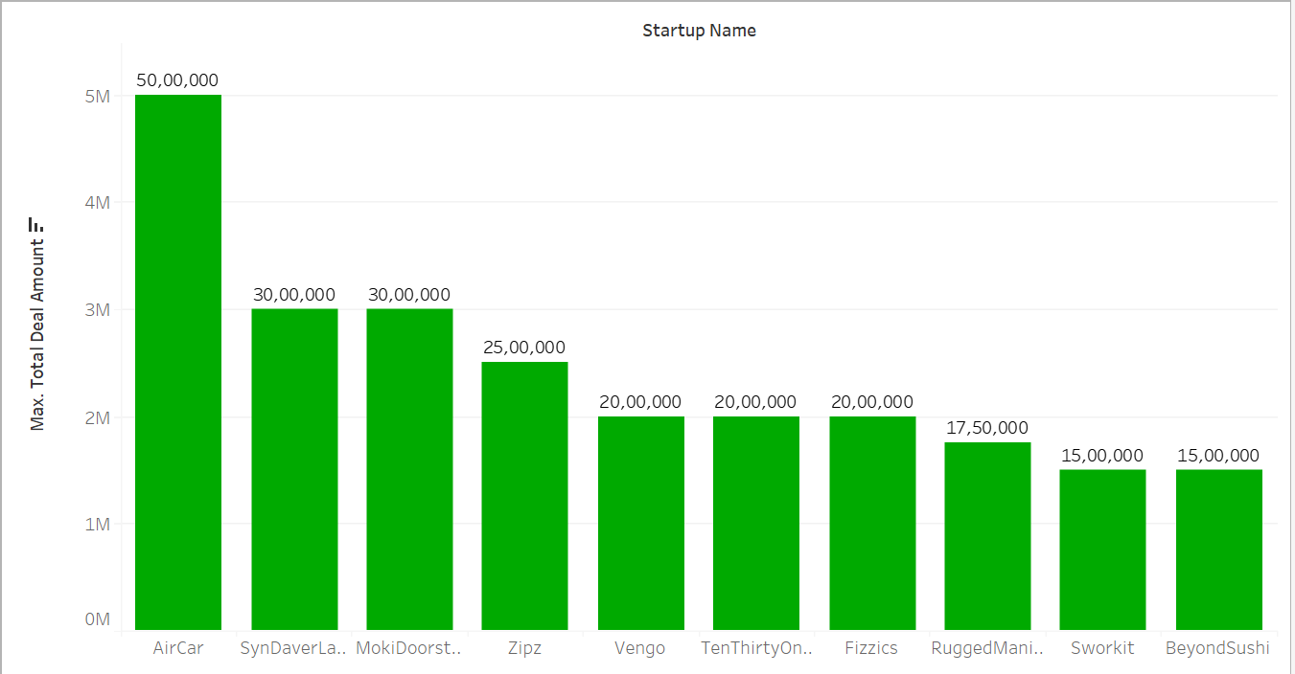**Tableau Plot:-**

1. **Top-3 Industries with the highest deals in the shark tank?**

**Code:-**

Industry_Count = pd.DataFrame(Dataset.groupby("Industry")["Total Deal Amount"].max().rename("Total Deal Amount")).sort_values(by="Total Deal Amount", ascending=False)[:3]

print(Industry_Count.columns)

colors = plt.cm.get_cmap("tab10", 3)

plt.figure(figsize=(20,8))

plt.bar(x=Industry_Count.index,height=Industry_Count["Total Deal Amount"],width=0.5,color=colors(range(3)),)

for i,value in enumerate(Industry_Count['Total Deal Amount']) :

plt.text(i, value, str(value) , ha="center" , va="bottom" , weight = "bold")

plt.show()

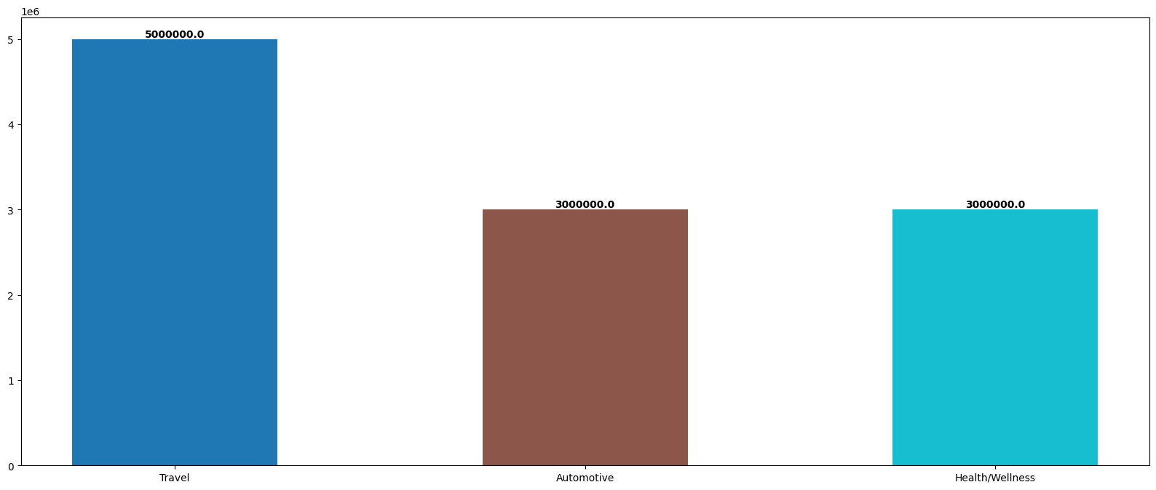**Output:-**

**Tableau Plot:-**

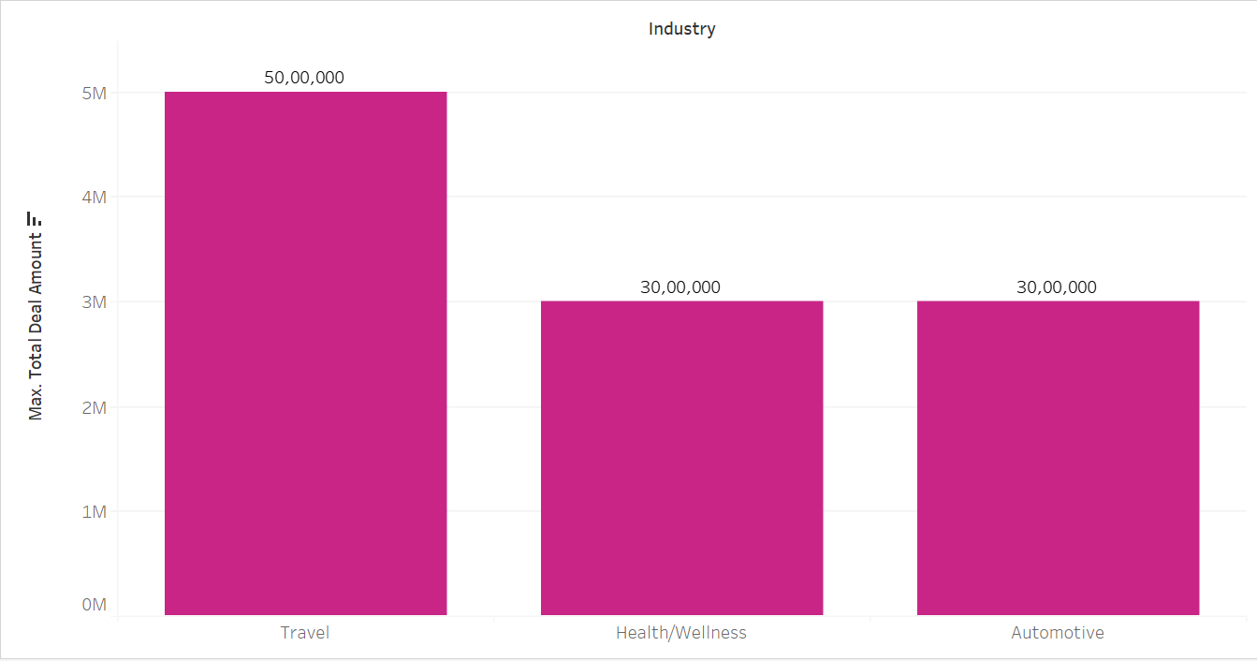

1. **Which are the top 5 cities with the maximum number of entrepreneurs?**

**Code:-**

City_Count = pd.DataFrame(Dataset["Pitchers City"].value_counts().rename("Counts")[:5])

plt.figure(figsize=(20, 10))

sns.barplot(x=City_Count.index, y="Counts", data=City_Count, hue=City_Count.index)

for i, value in enumerate(City_Count['Counts']):

plt.text(i, value, str(value), ha="center", va="bottom", weight="bold")

plt.xlabel("City")

plt.ylabel("Count")

plt.title("Top 5 Pitchers Cities")

plt.show()

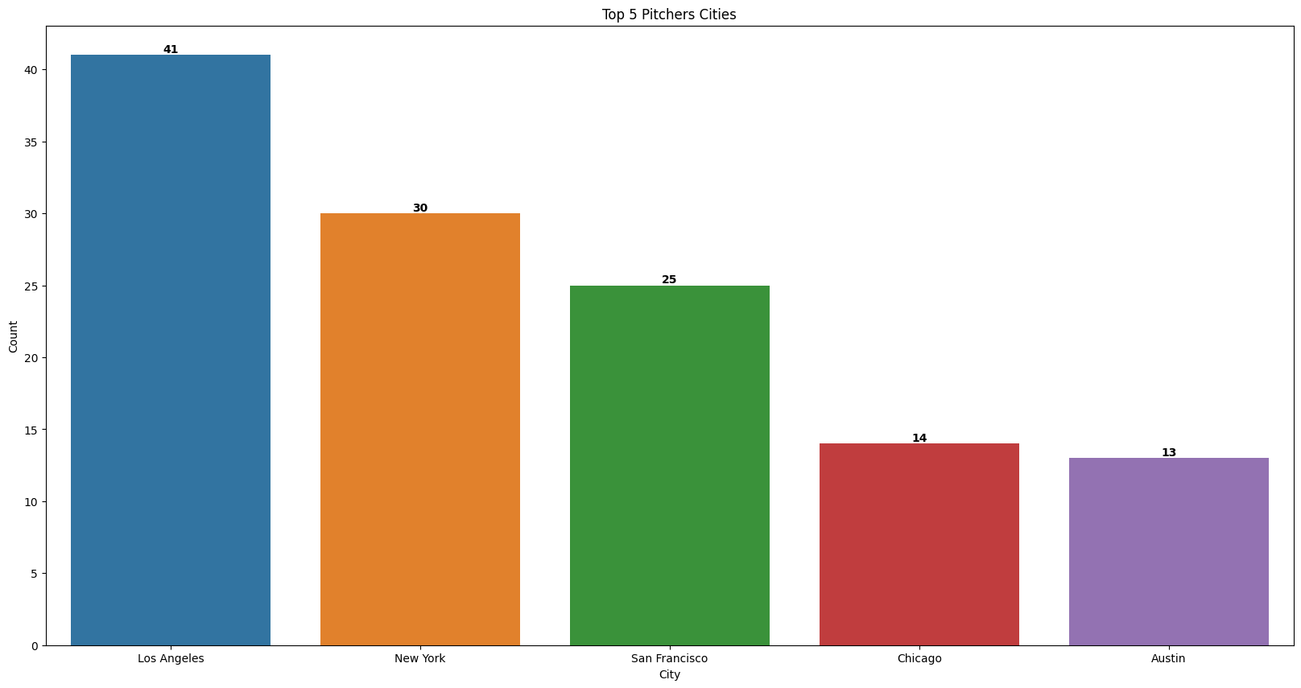**Output:-**

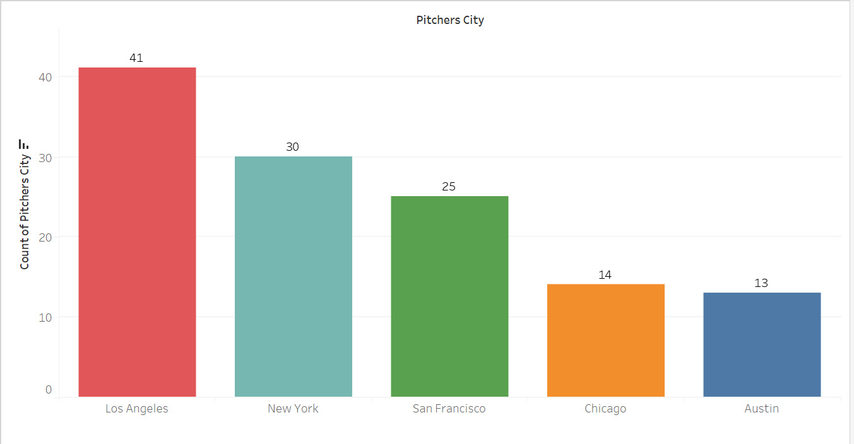**Tableau Plot:-**

1. **Which are the top 3 states that have got maximum number of deals?**

**Code:-**

State_Count = pd.DataFrame(Dataset["Pitchers State"].value_counts().rename('Counts'))[:3]

plt.figure(figsize=(20, 10))

sns.barplot(x=State_Count.index, y="Counts", data=State_Count, hue=State_Count.index)

for i, value in enumerate(State_Count["Counts"]):

plt.text(i, value, str(value), ha="center", va="bottom", weight="bold")

plt.xlabel("State")

plt.ylabel("Count")

plt.title("Top 5 Pitchers Cities")

plt.show()

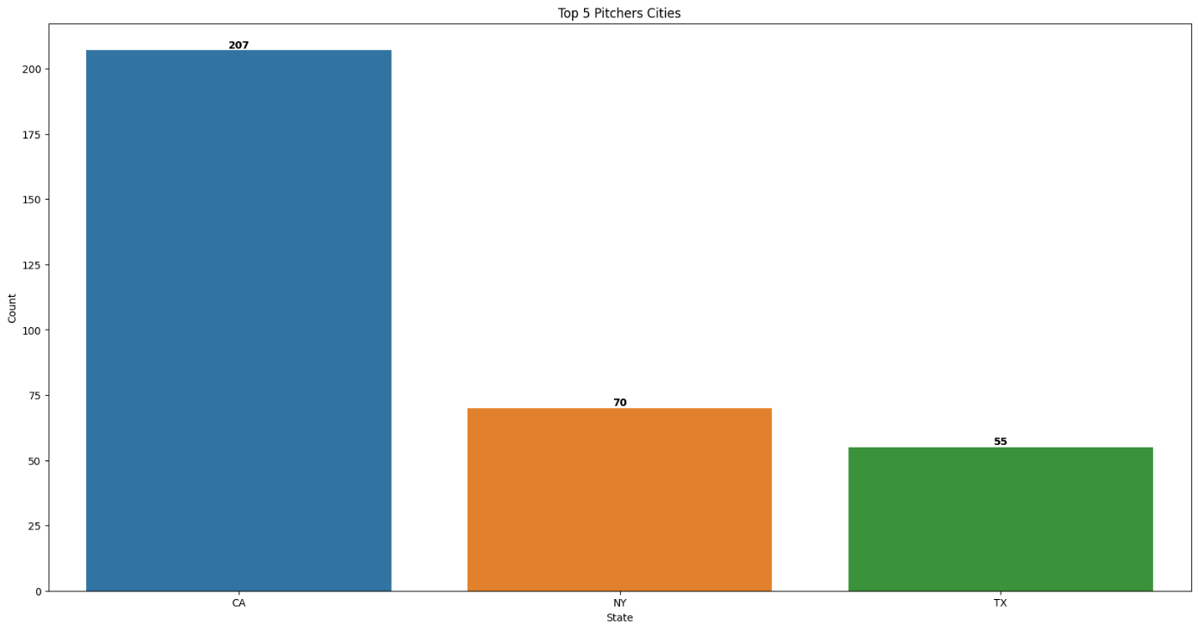**Output:-**

**Tableau Plot:-**

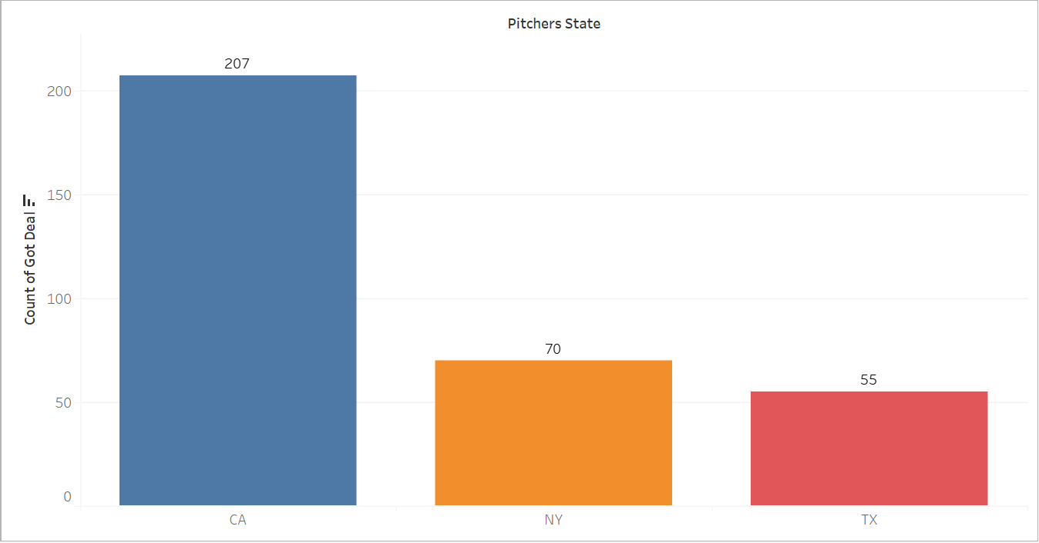

1. **Industry- wise count the total number of startups who pitched in the shark tank**

**Code:-**

Industry_Count = pd.DataFrame(Dataset["Industry"].value_counts().rename('Counts'))

plt.figure(figsize=(30, 10))

sns.barplot(x=Industry_Count.index, y="Counts", data=Industry_Count, hue=Industry_Count.index)

for i, value in enumerate(Industry_Count["Counts"]):

plt.text(i, value, str(value), ha="center", va="bottom", weight="bold")

plt.xlabel("Industry")

plt.ylabel("Count")

plt.title("Top 5 Pitchers Cities")

plt.show()

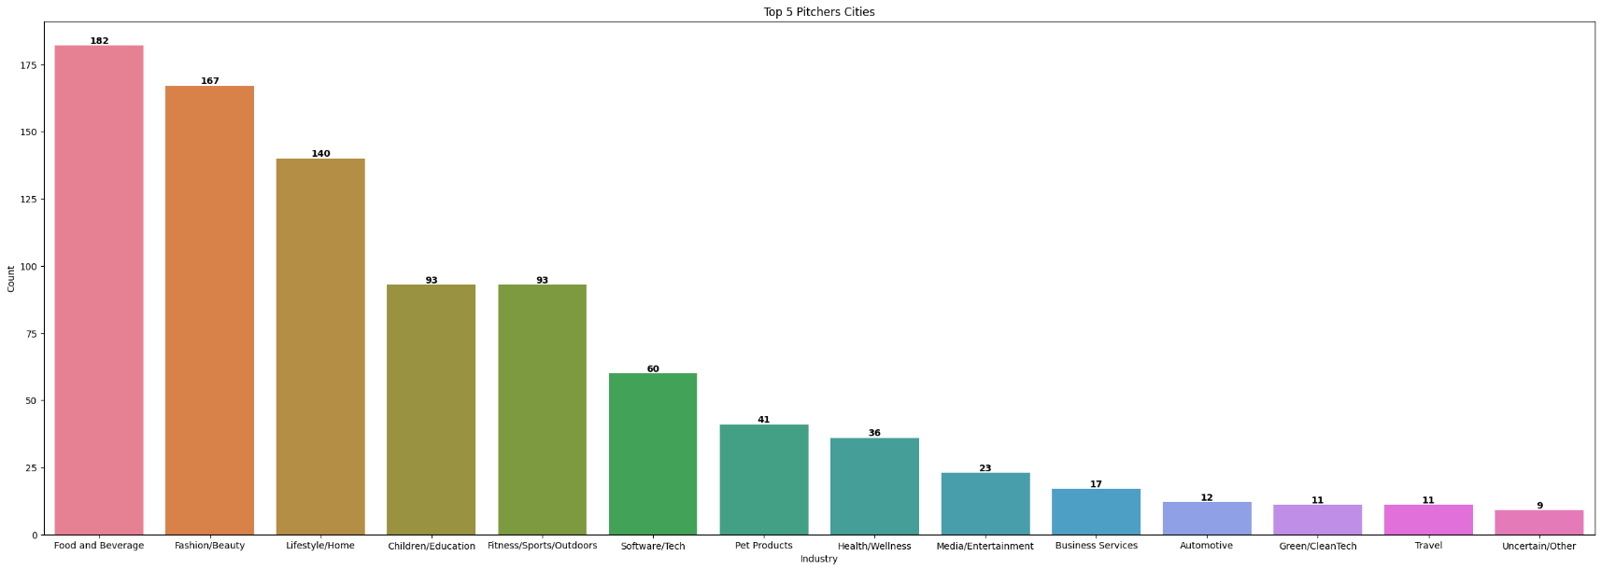**Output:-**

**Tableau Plot:-**

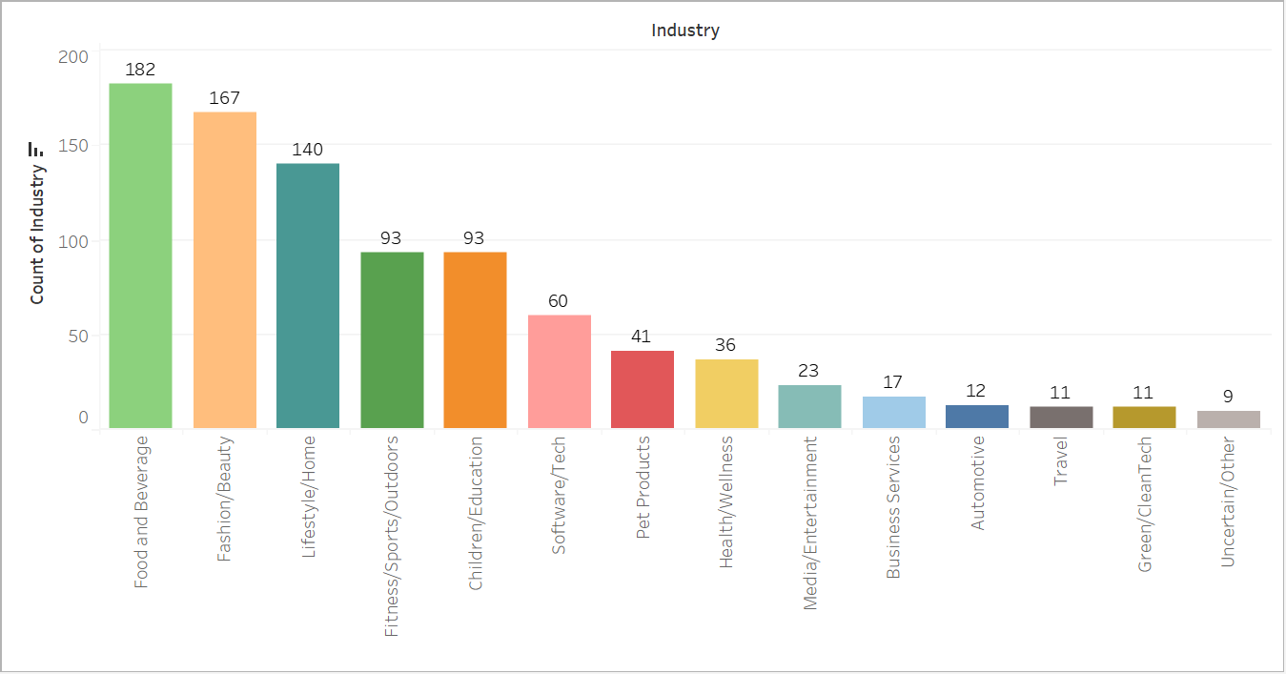

1. **Count the number of pitchers who are male, and female and belong to the mixed team**

**Code:-**

Gender_Count = pd.DataFrame(Dataset["Pitchers Gender"].value_counts().rename('Counts'))

plt.figure(figsize=(30, 10))

sns.barplot(x=Gender_Count.index, y="Counts", data=Gender_Count, hue=Gender_Count.index)

for i, value in enumerate(Gender_Count["Counts"]):

plt.text(i, value, str(value), ha="center", va="bottom", weight="bold")

plt.xlabel("Gender")

plt.ylabel("Count")

plt.title("Top 5 Pitchers Cities")

plt.show()

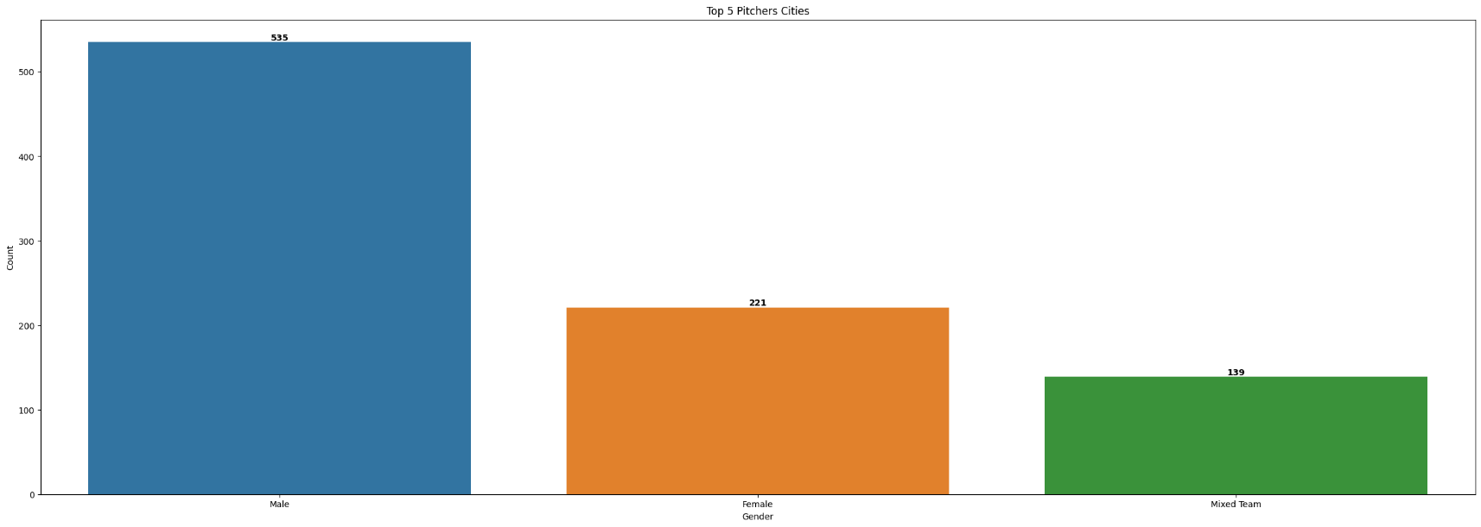**Output:-**

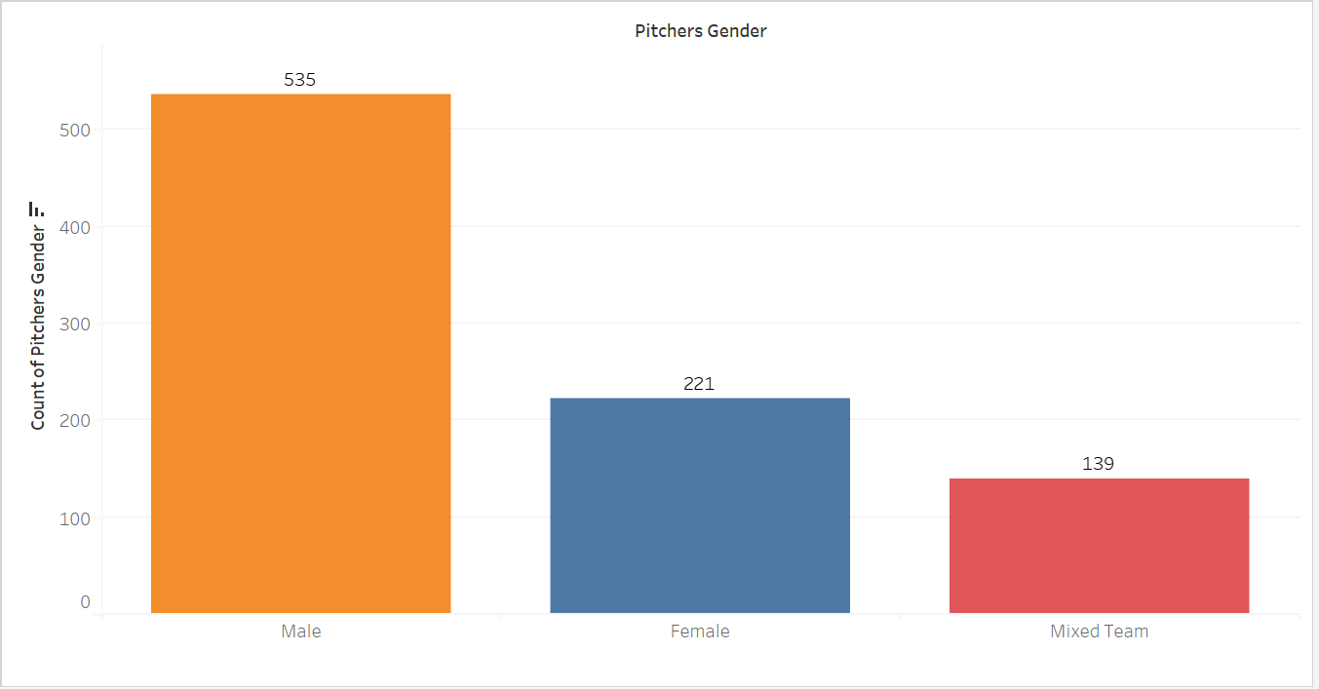**Tableau Plot:-**

1. **Find the maximum amount requested by a pitcher in each industrial segment**

**Code:-**

Industry_Wise_Deal_Amount = (Dataset.groupby("Industry")["Original Ask Amount"].max().reset_index())

Industry_Wise_Deal_Amount = Industry_Wise_Deal_Amount.sort_values(by = 'Original Ask Amount' , ascending = False)

plt.figure(figsize=(30,20))

sns.barplot(data=Industry_Wise_Deal_Amount,x="Industry",y="Original Ask Amount",hue="Industry",)

for i,value in enumerate(Industry_Wise_Deal_Amount['Original Ask Amount']) :

plt.text(i, value, str(value), ha="center", va="bottom", weight="bold")

plt.xlabel("Industry")

plt.ylabel("Ask Amount")

plt.title("Industry Wise MAximum amount Asked")

plt.show()

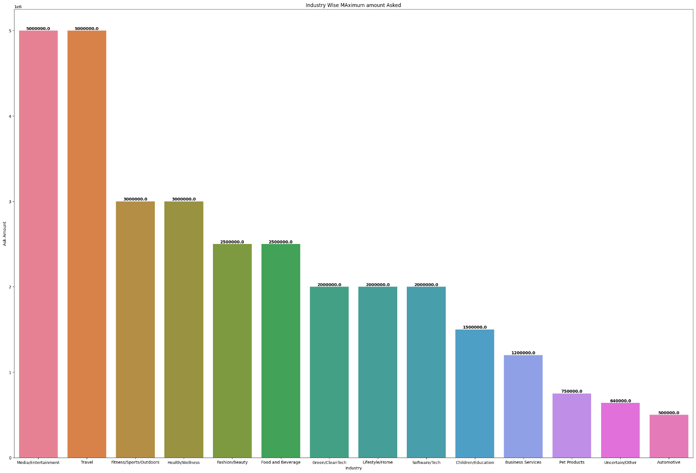**Output:-**

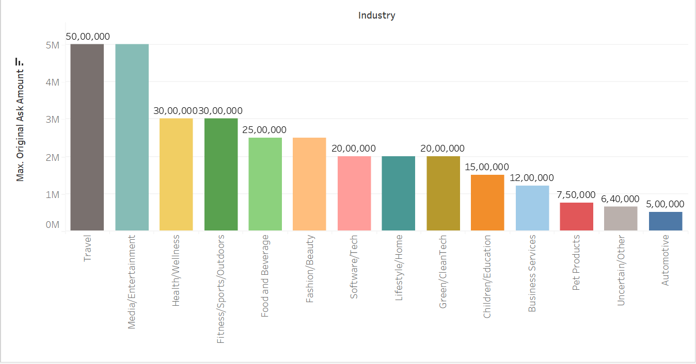**Tableau Plot:-**

1. **Find the maximum equity received by a shark in each industrial segment**

**Code:-**

Industry_Wise_Received_Equity = Dataset.groupby("Industry")["Total Deal Equity"].max()

Industry_Wise_Received_Equity = pd.DataFrame(Industry_Wise_Received_Equity)

Industry_Wise_Received_Equity = Industry_Wise_Received_Equity.sort_values(by="Total Deal Equity", ascending=False)

plt.figure(figsize=(30, 15))

sns.barplot(data=Industry_Wise_Received_Equity.reset_index(),x="Industry", y="Total Deal Equity",hue="Industry")

for i,value in enumerate(Industry_Wise_Received_Equity['Total Deal Equity']) :

plt.text(i , value , str(value), ha = "center" , va = "bottom" , weight = "bold")

plt.xticks(rotation=45)

plt.xlabel("Industry")

plt.ylabel("Total Deal Equity")

plt.title("Industry-wise Total Deal Equity")

plt.show()

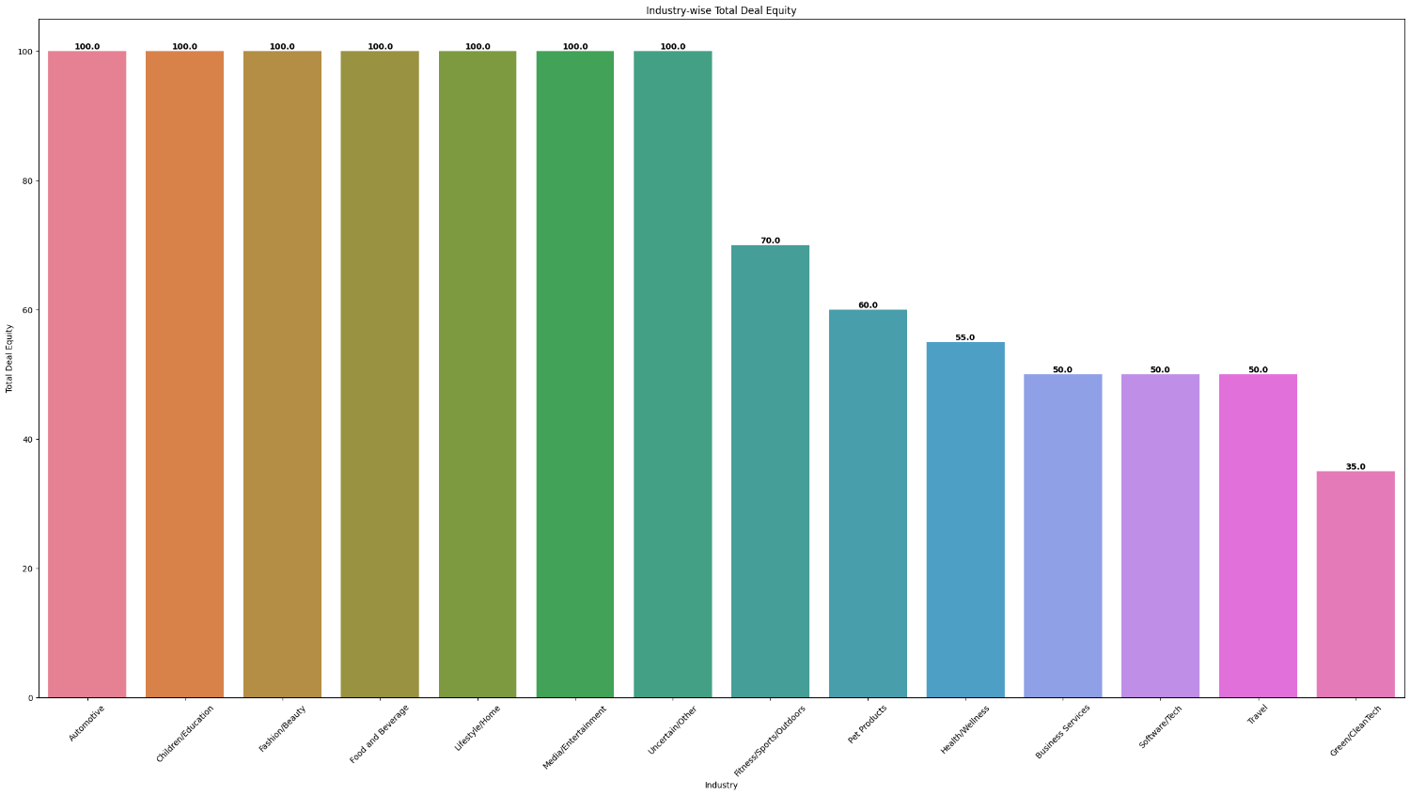**Output:-**

**Tableau Plot:-**

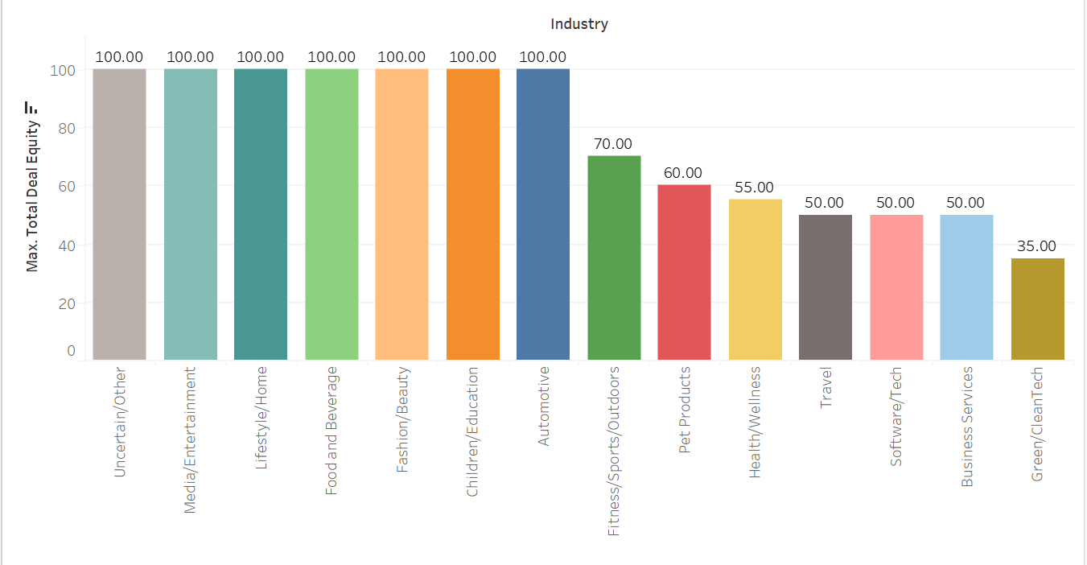

1. **Find the total amount invested by each shark throughout the shark tank**

**Code:-**

Dataset = Dataset.fillna(0)

Investments_of_Sharks = {}

Investments_of_Sharks['Shark_Name'] = []

Investments_of_Sharks['Amount'] = []

Column_Name = ["Barbara Corcoran Investment Amount","Mark Cuban Investment Amount","Lori Greiner Investment Amount","Robert Herjavec Investment Amount","Daymond John Investment Amount","Kevin O Leary Investment Amount","Guest Investment Amount"]

for i in Column_Name :

Shark_Name = i.split(' ')

Investments_of_Sharks["Shark_Name"].append(Shark_Name[0] + " " + Shark_Name[1])

Investments_of_Sharks['Amount'].append(Dataset[i].sum())

Investments_of_Sharks = pd.DataFrame(Investments_of_Sharks).sort_values(by = "Amount" , ascending=False)

pd.options.display.float_format = '{:.2f}'.format

plt.figure(figsize=(30,15))

sns.barplot(data=Investments_of_Sharks.reset_index(), x="Shark_Name", y="Amount", hue="Shark_Name")

for i,value in enumerate(Investments_of_Sharks['Amount']) :

plt.text(i, value, str(value), ha = "center", va = "bottom", weight = "bold")

plt.xticks(rotation=45)

plt.xlabel("Shark Name")

plt.ylabel("Total Amount Invested")

plt.title("Total Amount Invested By Each Shark")

plt.show()

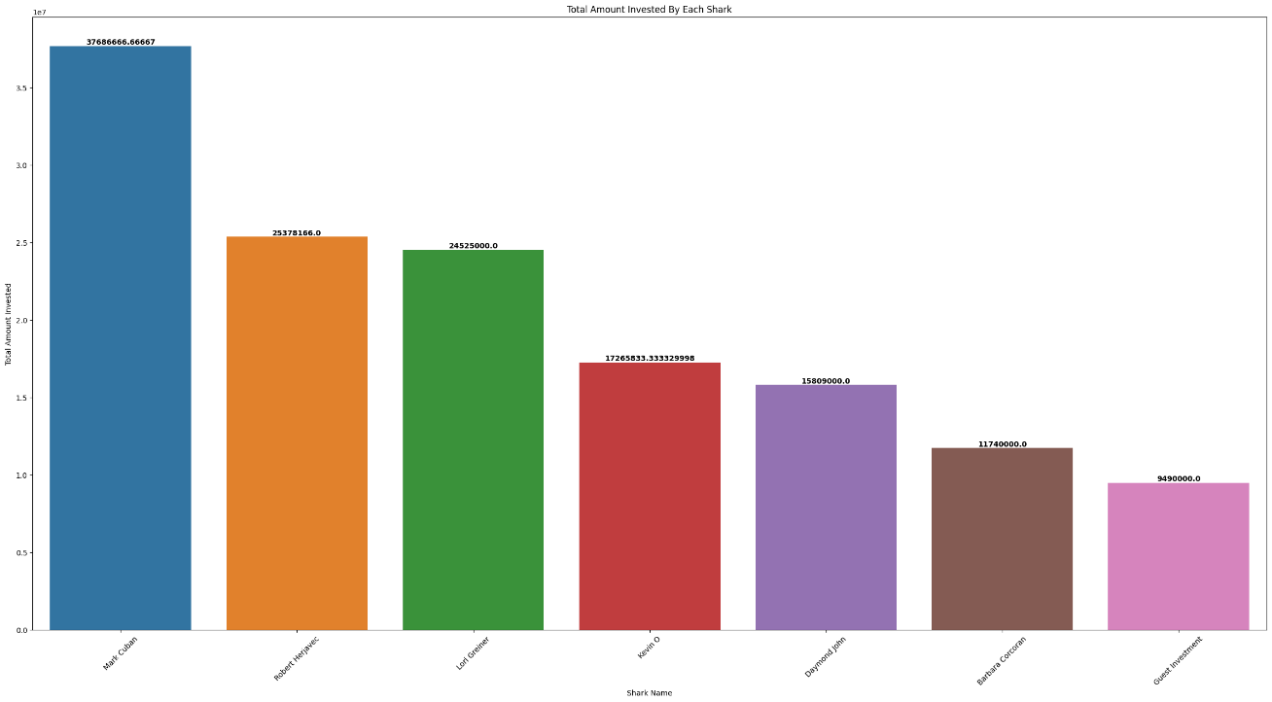**Output:-**

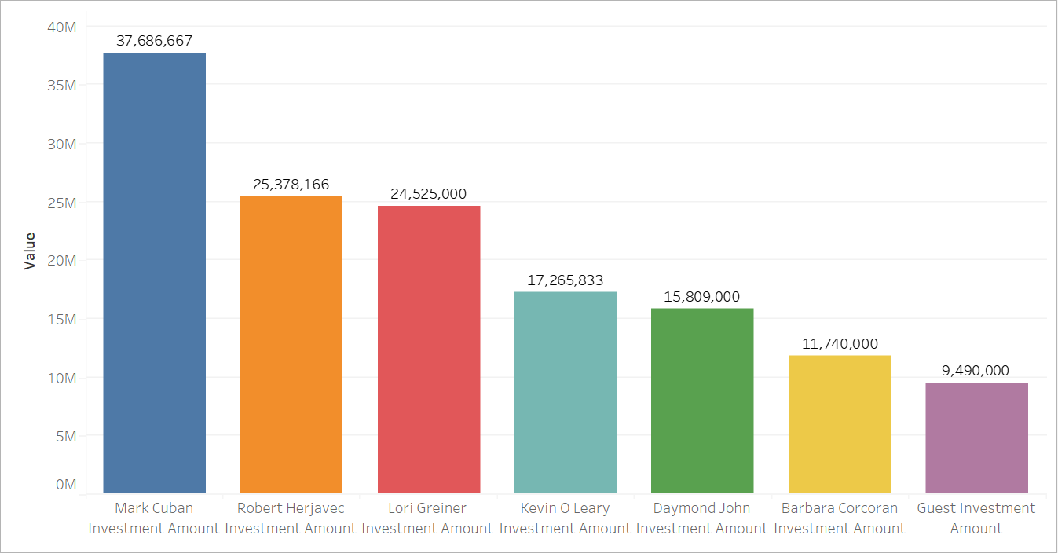**Tableau Plot:-**

1. **Name the startups with Top-15 investments**

**Code:-**

Sorted_Deal = Dataset.sort_values(by="Total Deal Amount" , ascending=False).reset_index()[:15]

print(Sorted_Deal[["Startup Name" , "Total Deal Amount"]])

plt.figure(figsize=(30, 15))

sns.barplot(data=Sorted_Deal,x="Startup Name",y="Total Deal Amount",hue="Startup Name")

for i, value in enumerate(Sorted_Deal["Total Deal Amount"]):

plt.text(i, value, str(value), ha="center", va="bottom", weight="bold")

plt.xticks(rotation=45)

plt.xlabel("Startup Name")

plt.ylabel("Total Amount Received")

plt.title("Top 15 Investment")

plt.show()

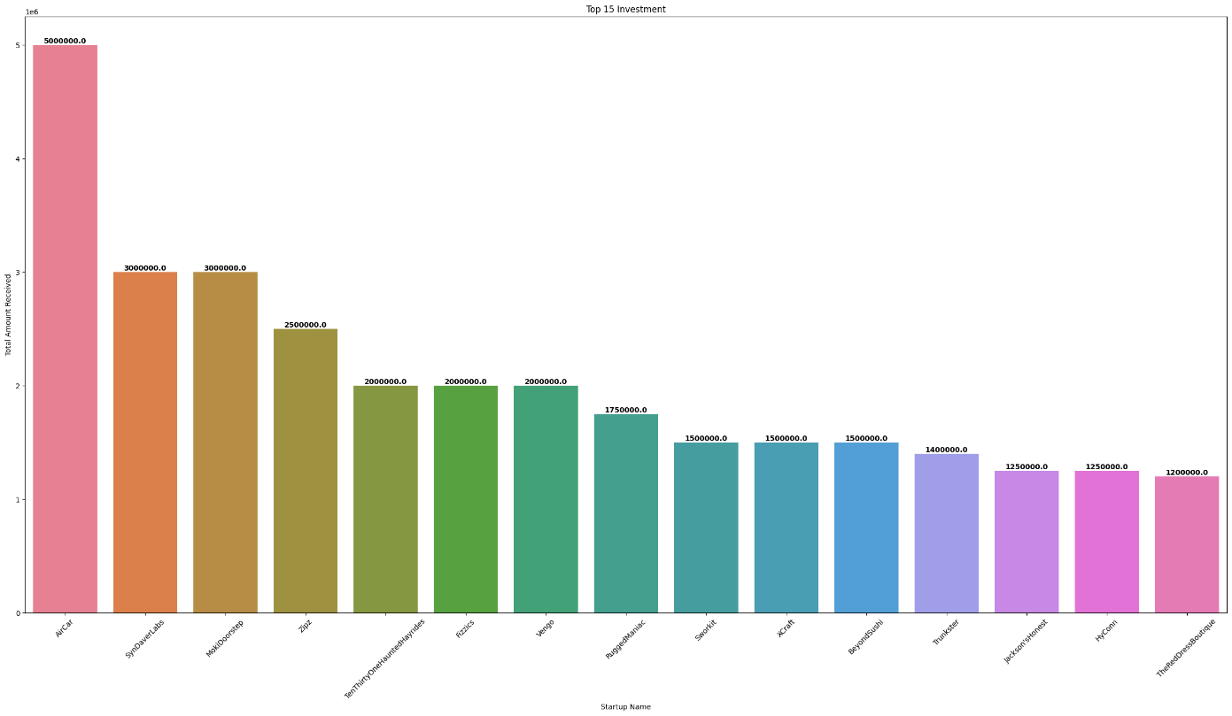**Output:-**

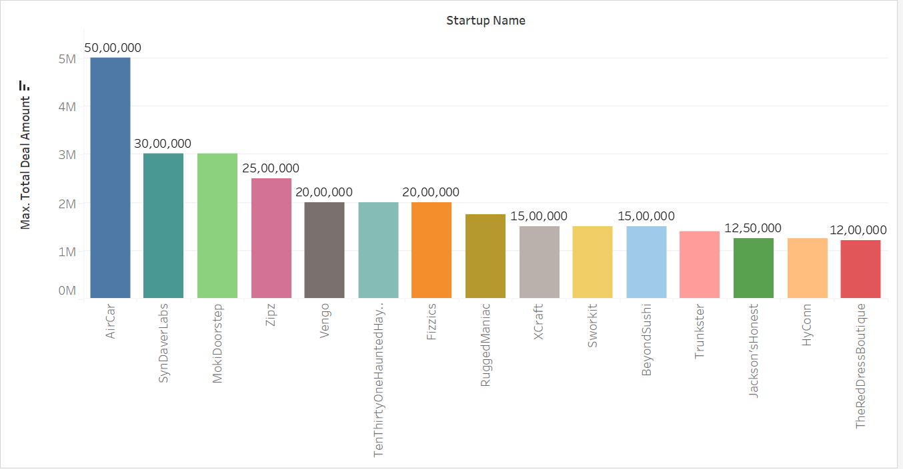**Tableau Plot:-**

1. **Find the number of deals having [1,2,3,4,5] sharks included in the deal**

**Code:-**

plt.figure(figsize=(26,13))

sns.countplot(x=Dataset["Number of sharks in deal"],hue=Dataset["Number of sharks in deal"],order=Dataset["Number of sharks in deal"].value_counts(ascending=False).index,)

for i, value in enumerate(Dataset["Number of sharks in deal"].value_counts()):

plt.text(i, value, str(value), ha="center", va="bottom", weight="bold")

plt.xticks(rotation=45)

plt.xlabel("No. of Sharks")

plt.ylabel("No. of Deals")

plt.title("No of Deals vs No. of Sharks")

plt.show()

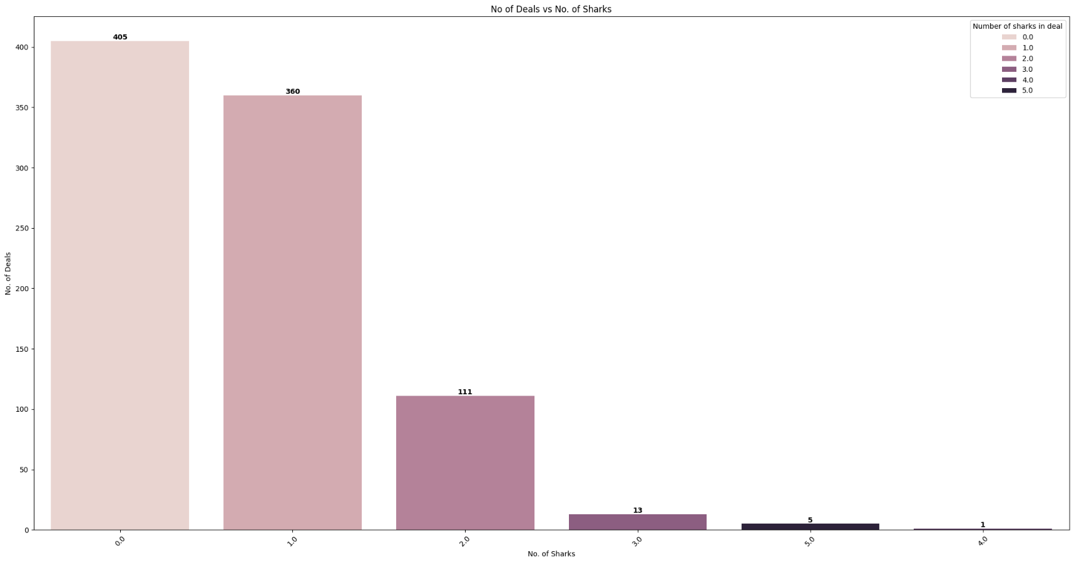**Output:-**

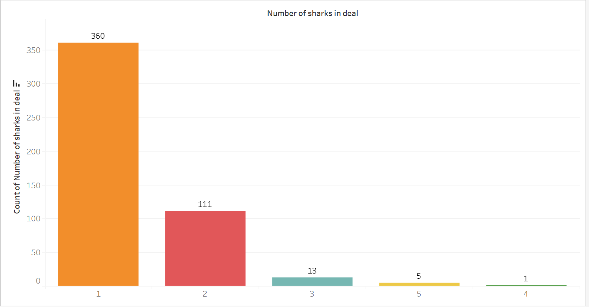**Tableau Plot:-**

1. **Which are the top 3 industries where "Kevin O Leary" is more interested in investing?**

**Code:-**

Dataset = Dataset.fillna(0)

Kevin_O_Leary_Interestered_Industries = Dataset.groupby("Industry")["Kevin O Leary Investment Amount"].sum()

Kevin_O_Leary_Interestered_Industries = pd.DataFrame(Kevin_O_Leary_Interestered_Industries)

Kevin_O_Leary_Interestered_Industries = Kevin_O_Leary_Interestered_Industries.sort_values(by="Kevin O Leary Investment Amount" , ascending=False )

Kevin_O_Leary_Interestered_Industries = Kevin_O_Leary_Interestered_Industries[:3]

print(Kevin_O_Leary_Interestered_Industries)

plt.figure(figsize=(30, 15))

sns.barplot(data=Kevin_O_Leary_Interestered_Industries, x=Kevin_O_Leary_Interestered_Industries.index, y="Kevin O Leary Investment Amount", hue=Kevin_O_Leary_Interestered_Industries.index)

for i, value in enumerate(Kevin_O_Leary_Interestered_Industries["Kevin O Leary Investment Amount"]):

plt.text(i, value, str(value), ha="center", va="bottom", weight="bold", fontsize=20)

plt.title("Top 3 Industries by Kevin O'Leary Investment Amount", fontsize=25)

plt.xlabel("Industry", fontsize=20)

plt.ylabel("Total Investment Amount", fontsize=20)

plt.xticks(fontsize=14)

plt.yticks(fontsize=14)

plt.tight_layout()

plt.show()

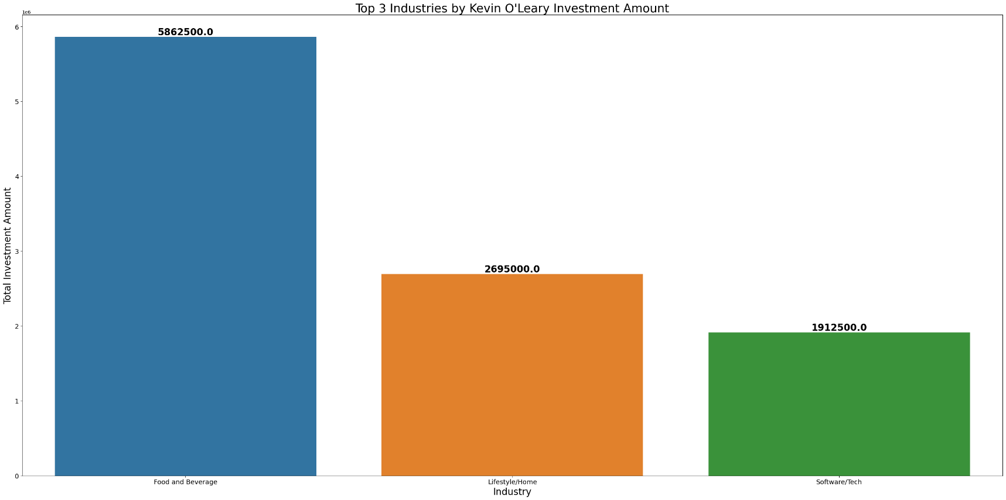**Output:-**

**Tableau Plot:-**

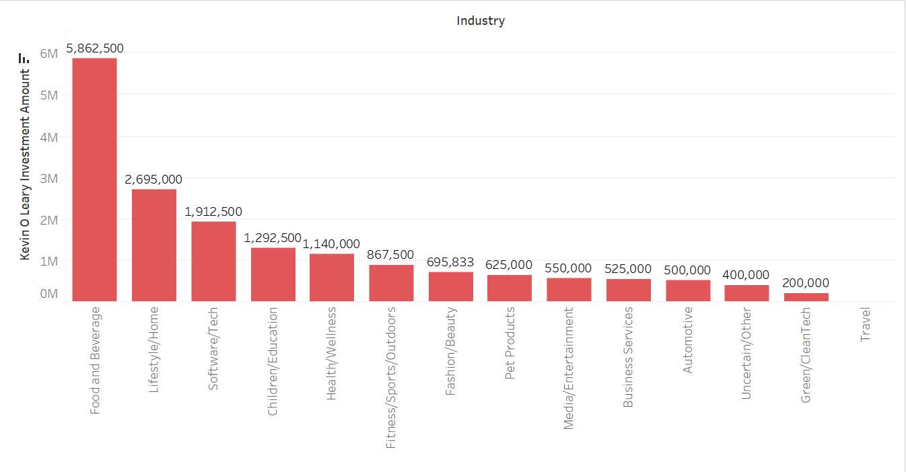

1. **Which are the 3 least favored industries by the sharks?**

**Code:-**

Least_Favoured_Industry = Dataset.groupby("Industry")["Total Deal Amount"].sum()

Least_Favoured_Industry = pd.DataFrame(Least_Favoured_Industry)

Least_Favoured_Industry = Least_Favoured_Industry.sort_values(by="Total Deal Amount" , ascending= True)

Least_Favoured_Industry = Least_Favoured_Industry[:3]

print(Least_Favoured_Industry)

plt.figure(figsize=(30, 15))

sns.barplot(data=Least_Favoured_Industry, x=Least_Favoured_Industry.index, y="Total Deal Amount", hue=Least_Favoured_Industry.index)

for i, value in enumerate(Least_Favoured_Industry["Total Deal Amount"]):

plt.text(i, value, str(value), ha="center", va="bottom", weight="bold", fontsize=20)

plt.title("Top 3 Least Favored Industries", fontsize=25)

plt.xlabel("Industry", fontsize=20)

plt.ylabel("Total Investment Amount", fontsize=20)

plt.xticks(fontsize=14)

plt.yticks(fontsize=14)

plt.tight_layout()

plt.show()

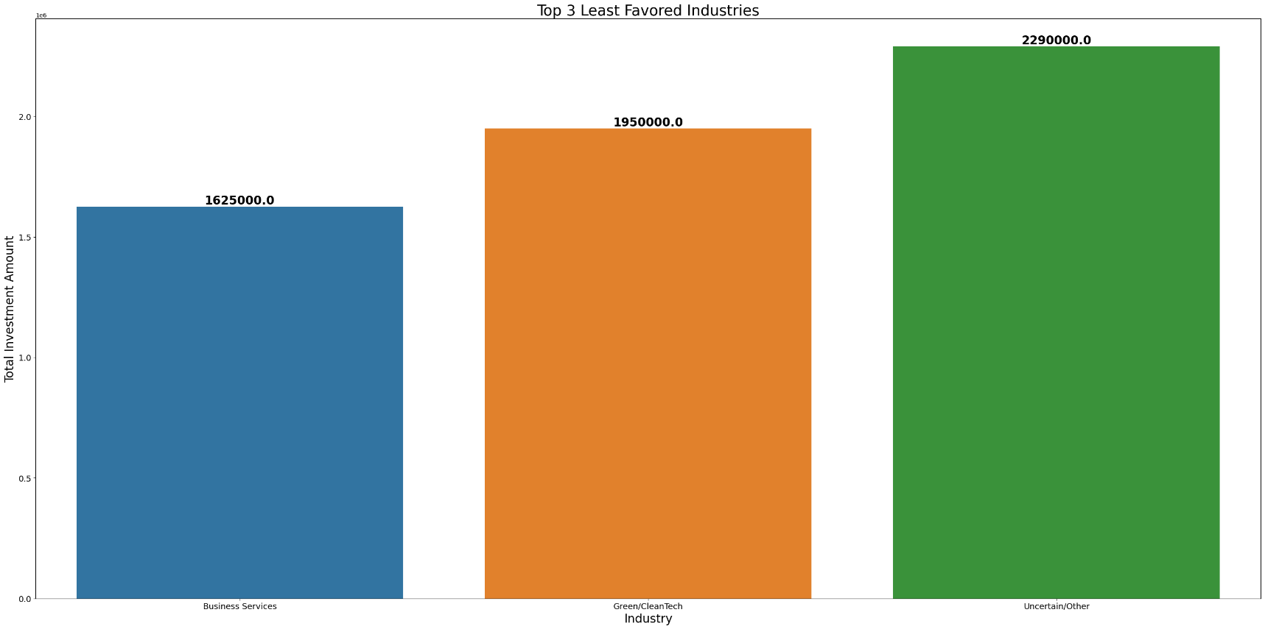**Output:-**

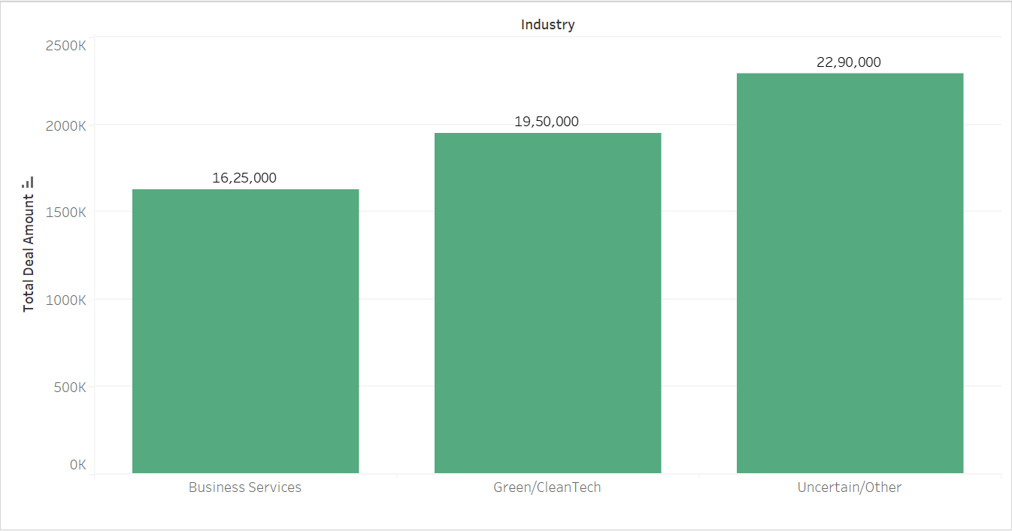**Tableau Plot:-**

1. **Give your conclusion over the entire analysis, depicting the overall inference from the dataset.**

* By performing this analysis if we can get an inference then it is showing how the startup culture of the USA is working which kinds of startups are been started and running successful businesses and we can also come to know the interest in investments of each and every sharks.